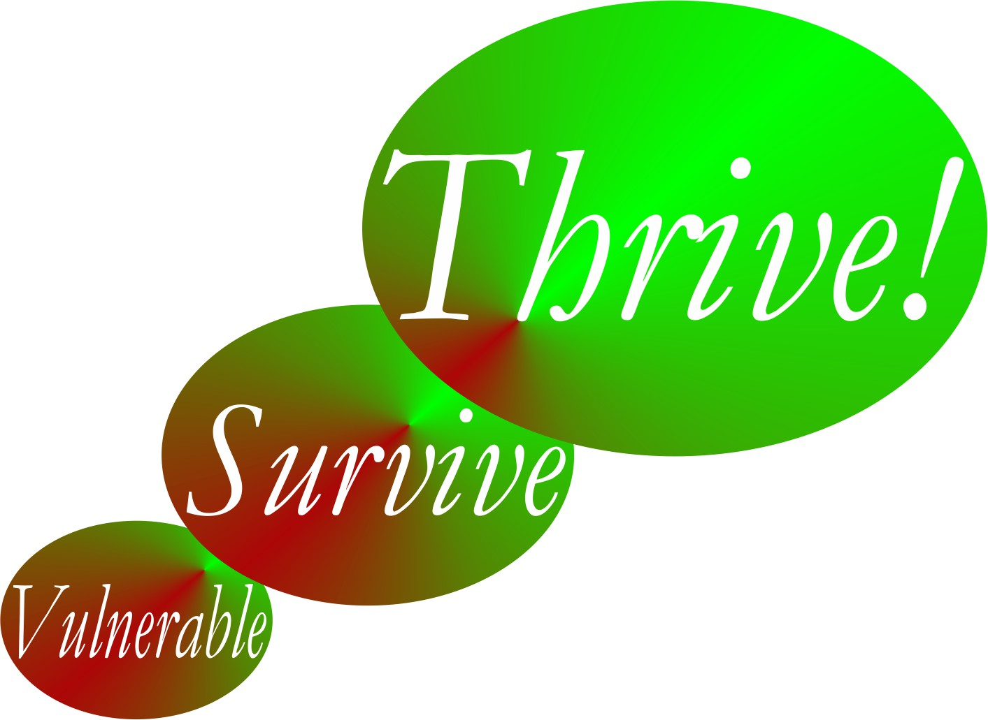

Thrive!® - People’s Guide To A Thriving Future

[For All Forever]

Worksheets for Our World

Final Draft

by

Gary Chris Christopherson

Founder of
Thrive!® - Building a Thriving Future for All Forever
HealthePeople® - Building a Healthy and Thriving Future

Nelson, WI University Park, MD

Copyright © 2014 Gary Chris Christopherson All rights reserved.

World Characteristics | What is our world today?
Geographic boundaries
Gender make-up
Age make-up
Racial make-up
Ethnic make-up
Lifestyle
Type of work
Financial situation
Food/drink
Housing
Protection
Education
Physical / mental health
Personal growth / development
Habitat
Producing what
Climate
Sustainability
Table 7.1. What is our world today?

Thriving and Surviving | How well (thriving/surviving) is our world? | What positively/negatively impacts its thriving/ surviving now? | What is its near/ long term future behavior as to thriving/ surviving?
Performing (live/work/play) well?
Well-off?
Well nourished?
Well housed?
Well protected?
Well educated?
Physically/ mentally well?
Growing/ developing well?
Living in good habitat?
Not vulnerable?
Producing personal/ public goods?
Stable, positive climate?
Sustainable?
Table 7.2. How well (thriving/surviving) is our world? What positively/negatively impacts it? What is its near/long term future behavior?

World Characteristics | What is our desired and/or likely future world?
Type of work/how people live
Financial situation
Food/drink
Housing
Protection
Education
Physical / mental health
Personal growth / development
Habitat
Producing what
Climate
Sustainability
Table 7.3. What is our desired and/or likely future world?

Thriving and Surviving | How well (thriving/surviving) should our world be in near/long term future? | Changes needed to achieve thriving and surviving future | Actions - Who will do what to/with whom, where, when, and with what result?
Performing (live/work/play) well?
Well-off?
Well nourished?
Well housed?
Well protected?
Well educated?
Physically/ mentally well?
Growing/ developing well?
Living in good habitat?
Not vulnerable?
Producing personal/ public goods?
Stable, positive climate?
Sustainable?
Table 7.4. Thrive! Strategy and Action Plan. How well (thriving/surviving) should our world be in near/long term future? What changes are needed to achieve our world’s thriving future? To make this happen, what actions are needed?

