Thrive!® -

People’s Guide To A Thriving Future

[For All Forever]

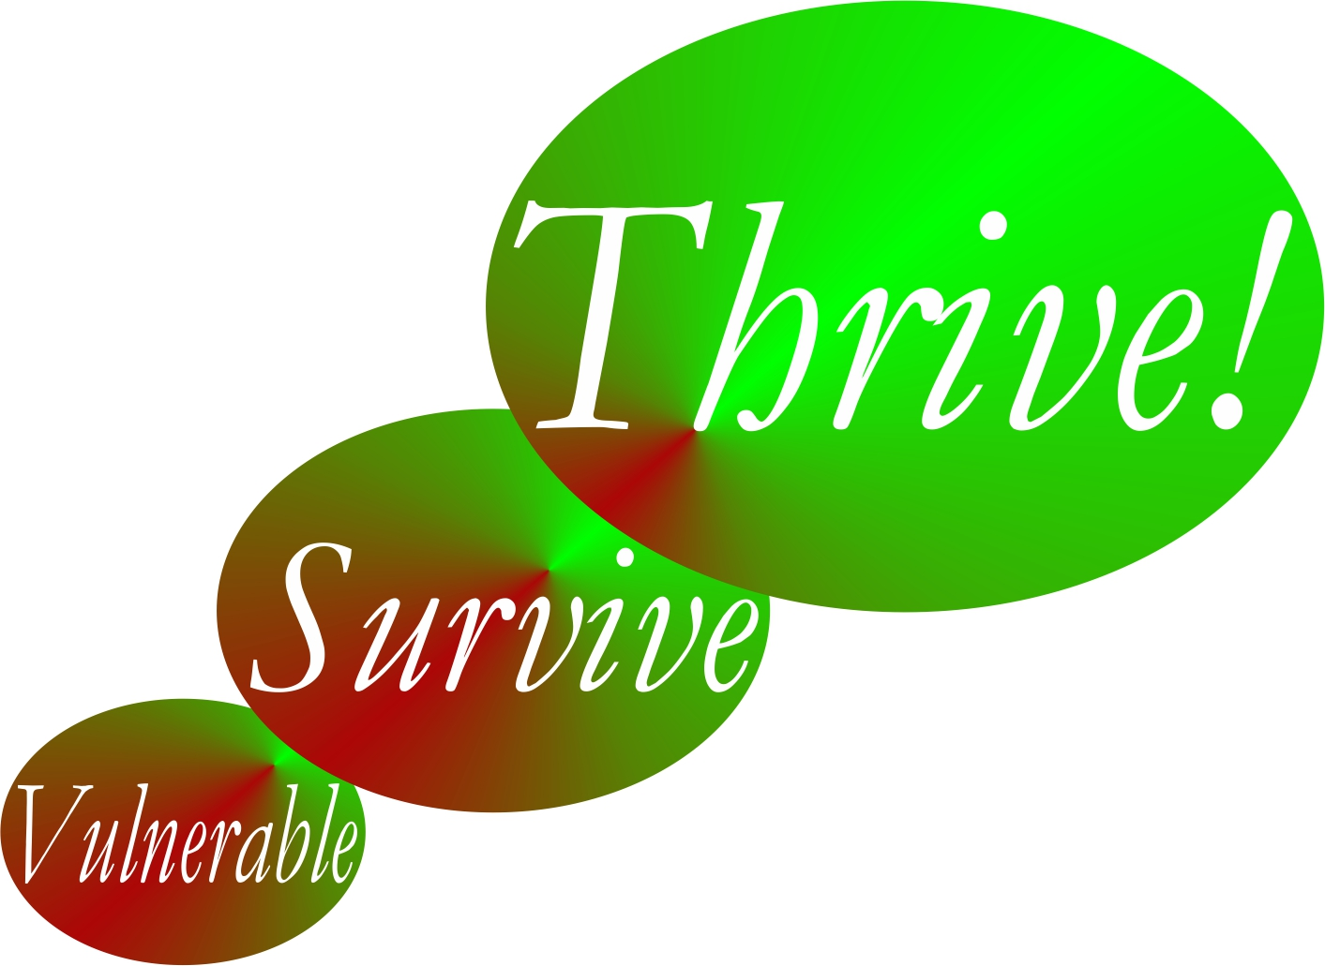

by

Gary “Chris” Christopherson

Founder, Thrive!® - Building a Thriving Future for All Forever
Founder, HealthePeople® - Building a Healthy and Thriving Future

Nelson, WI University Park, MD

Copyright © 2014 Gary Chris Christopherson

All rights reserved.
Thrive!® - People’s Guide To A Thriving Future
[For All Forever]

Complete Guide to a Thriving Future  [With Examples and Worksheets] | Complete Guide Page
Chapter 1: How to use this People’s Guide.
How to use People’s Guide to help you and your family and friends, community, country and world survive and thrive.
Chapter 2: What a thriving future will be.
What your life and our world will be in a thriving future where all survive and thrive forever.
Chapter 3: Why you and all of us must care about a thriving future.
Why you and we must care about a surviving and thriving future for you, friends and family, community, country, and world.
Chapter 4: How you and your family and friends can thrive.
How to build, achieve and sustain a surviving and thriving future for you and family and friends.
Chapter 5: How you and your community can thrive.
How to build, achieve and sustain a surviving and thriving future for you and your community.
Chapter 6: How you and your country can thrive.
How to build, achieve and sustain a surviving and thriving future for you and your country.
Chapter 7: How our world can thrive.
How to build, achieve and sustain a surviving and thriving future for our world.
Chapter 8: How the Thrive! Endeavor, you and all of us together, builds a thriving future.
How Thrive! Endeavor, you and all of us together, builds, achieves and sustains a surviving and thriving future for all forever.
Appendix: Thrive! Next Generation Toolkit.
Strategy, policy and tools for creating and sustaining large, positive change and building a thriving future.
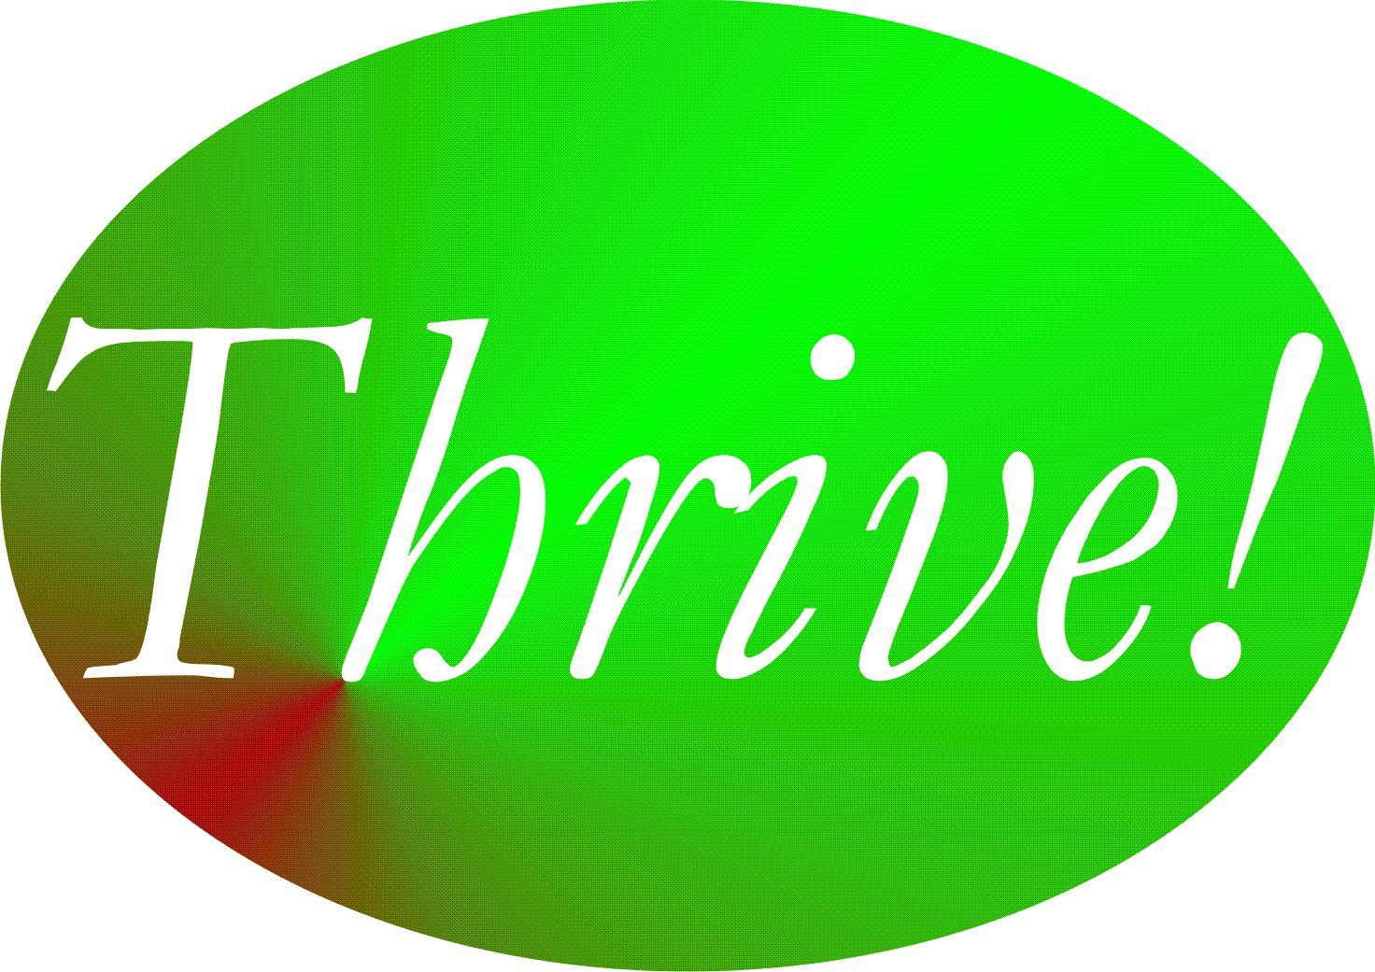

Appendix: Thrive! Next Generation Toolkit

Strategy, policy and tools for creating and sustaining large, positive change and building a thriving future.

If we are to achieve a better future, we need “next generation” strategies for solving large problems and creating and sustaining positive, large and timely change. We need them to build and sustain a thriving future. Thrive! (including viaFuture and the supportive via) strategies, models and tools are “next generation” strategy.,

Thirty years of experience at the national and local levels strongly suggests that most current policy and strategy models are too limited in scope for addressing today’s problems and wholly inadequate for succeeding with a much more challenging future. No single strategy, model or tool by itself will help us do all this. However, a “next generation” strategic framework coupled with a core set of “next generation” strategies, models and tools together can help. The core set and system of supportive models addresses persons, systems, motivation, ability, behavior, performance and its improvement, process measures, and, most importantly, positive outcomes and improved status.
Why Thrive! Next Generation Framework And Supportive Strategies

Going back to what it means to be “next generation”, here is how they match up to the need.
- First, they focus on individual “persons” -- individuals with unique abilities, motivation, and behaviors uniquely affected by and affecting their “environment.” “Person” aspects are addressed by the Behavioral Effectiveness Model (BEM) and the “Person-centered Model”. They have been used to help improve health and health care.
- Second, they are designed to be more effective at addressing issue areas, especially large, complex ones. Large, complex issue areas (e.g., health) have been addressed with them.
- Third, they are designed to effectively handle the cross-cutting issues of a highly interactive and interdependent world. Cross-cutting issue areas, including health and vulnerability, have been explored with the full via strategy core set.
- Fourth, they are designed to tackle issues as a system (e.g. a health system) interacting with other systems and within larger systems (e.g. communities, nations, broader areas). Systems (personal health, health care delivery systems, and public health) have been addressed with the full via strategy core set, including the “system” models.
- Fifth, they are designed to effectively handle “whole” systems, including whole communities, whole nations, and whole broader areas. Systems have been addressed (e.g., health system for America in context of America and the world) or explored (e.g., vulnerability, community, a nation) with the full via strategy core set.
- Sixth, they are designed to effectively handle the future in terms of sustaining whatever progress we make and adjusting to a changing future. Sustainable, future-adaptive systems have been addressed (e.g., personal health, large health care delivery systems) or explored (e.g., vulnerability, community, nation) with the full via strategy core set, including the predictive aspects of the core set’s models.

What Is The Thrive! Strategy Core Set And How Does It Work In Supporting Thrive!

The overall strategy and strategy core set is explored here along with three areas of potential application:
- Health, a large, complex, individual issue area, where it has already been applied.
- Vulnerability, a large complex cross-cutting issue area, where it is being explored to develop coordinated strategy and policy.
- Whole communities, whole nations and whole broader areas where it is being explored to develop coordinated strategy and policy.

What does the strategy core set include? As shown in Table A.1, the core set includes the overall Strategy, the Performance Improvement Model, the via Model, the Behavioral Effectiveness Model (BEM), the Person Model, the Population Model, the System(s) Model, the Strategy Model, and the Status Model. The overall core set and the supportive components can be applied to a single issue area, cross-cutting issue areas, and whole non-geographic populations, communities, nations and broader areas. Though this paper focuses on their use as a set, each can be used independently as well.

Overall Thrive! Strategy and Strategy Core Set.

What is it? As displayed in Figure A.1 and detailed in Table A.1, the overall strategy core set is to effectively use the strategy core set as a set of integrated, coordinated components to produce the necessary knowledge and an effective overall strategy with supportive strategies. By using the full core set, we can better identify and understand the targeted system (e.g., community, nation), decide what we want to achieve on a sustained basis, understand and select the target behaviors, design and select what interventions we need, and develop the overall strategy and supportive strategies to achieve the desired state. [Table A.1 and Figure A.1.]

Table A.1: Thrive! Strategy Core Set and Applicable Issue Levels and Scope
Strategy Core Set | Issue Level and Scope
Strategy Core Set | Single Issue  Area (E.g.  Health) | Cross-cutting  Issue Areas  (E.g. Vulnerability) | Whole  Community, Nation, Broader Areas
Overall Strategy | X | X | X
System(s) Model, Including “Ideal” Systems | X | X | X
Performance Improvement Model | X | X | X
via Model | X | X | X
Behavioral Effectiveness Model (BEM) | X | X | X
Person Model (applying BEM over individual person’s time & life stages) | X | X | X
Population Model (applying BEM over multiple persons’ time & life stages) | X | X | X
Strategy Model (strategies & interventions) | X | X | X
Status Model | X | X | X

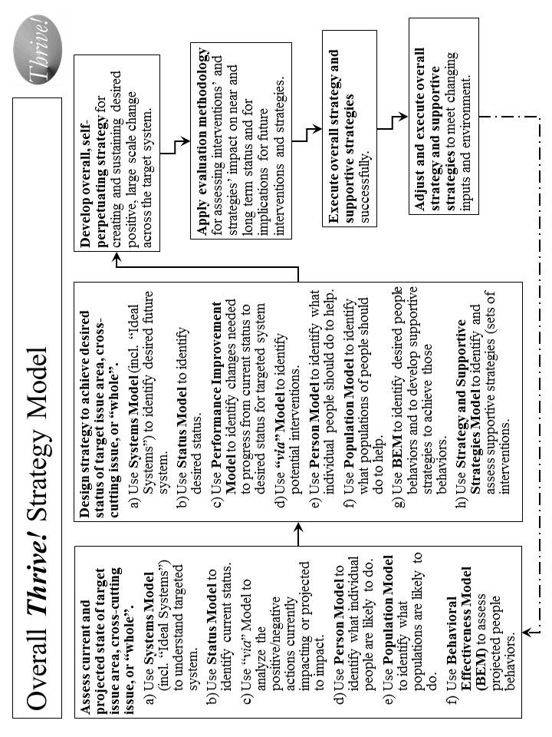

Figure A.1. Overall Thrive! Strategy Model.

How does it work? It works through the systematic application of the core set by people who have both the motivation and the ability to help create and sustain positive, large and timely change.

Though the steps in Table A.2 imply their sequential application that is not always the case. Step 1 is important in our understanding what is the current system, its status, its projected actions, and its projected people and population behaviors. Step 1c helps us organize that thinking of how we might get from the current situation to the desired status for the targeted system. Step 2 helps us work through what needs to be changed and how we might make that change. Step 3 pulls all this together to help us create and execute the overall strategy and supportive strategies. Step 4 is to make sure we evaluate how we are doing and provide input for changes in strategy. Step 5 focuses on the successful execution of the overall strategy and supportive strategies. Step 6 makes sure we understand that strategy is not static and needs to adjust to unanticipated input and environmental changes, and the strategy needs to be executed successfully on an ongoing basis.

How has it been used and helped? The Thrive! strategy core set has been used for several large scale changes, including systems such as the $15+ billion Military Health System (Department of Defense), the $1+ billion HealtheVet VistA health information system (Veterans Health Administration), the draft Strategic and Operational Plan for the $500+ billion Centers for Medicare and Medicaid Services, a potential strategy for reducing vulnerability for communities and nations, and a potential strategy for Building a Healthy America (over 1/6th of the U.S. economy).

Table A.2. Overall Thrive! Strategy -

Creating and Sustaining Positive, Large Change

The overall strategy for creating and sustaining positive, large change is as follows:
- Assess current and projected state of target issue area, cross-cutting issue, or “whole”.
  - Use Systems Model (including Ideal Systems) to understand targeted system (e.g. health system, community, nation, broader area) today.
  - Use Status Model to identify current status for “whole” (e.g., community, nation, broader areas), issue areas (e.g., health, education), or cross-cutting issue area (e.g., vulnerability, climate, habitat) targeted for positive, large scale change.
  - Use via Model to analyze positive/negative actions currently impacting or projected to impact issue, cross-cutting issue, or “whole”.
  - Use Person Model to identify what individual people are likely to do in future.
  - Use Population Model to identify what populations are likely to do in future.
  - Use Behavioral Effectiveness Model (BEM) to assess projected people behaviors.
- Design strategy to achieve desired status for target issue area, cross-cutting issue, or “whole”.
  - Use Systems Model (incl. “Ideal Systems”) to identify desired future system state.
  - Use Status Model to identify desired status for targeted system.
  - Use Performance Improvement Model to identify changes, including behavior, needed to progress from current status and achieve desired status for targeted system.
  - Use via Model to identify potential interventions for creating and sustaining desired positive, large scale change.
  - Use Person Model to identify what individual people should do to help achieve the desired positive, large scale change.
  - Use Population Model to identify what populations of people should do to help achieve the desired positive, large scale change.
  - Use BEM to identify ability, motivation and desired behaviors that help achieve desired change and to develop supportive strategies to achieve desired behaviors.
  - Use Strategy and Supportive Strategies Model to identify and assess and organize supportive strategies (sets of interventions) for creating/sustaining desired change.
- With above inputs, develop overall, self-perpetuating strategy for creating and sustaining desired positive, large scale change across target system.
- Apply evaluation methodology for assessing strategies/interventions impact on near and long term status and implications for future interventions/strategies.
- Execute overall strategy and supportive strategies successfully.
- Adjust and execute overall strategy and supportive strategies to meet changing inputs and environment.

In 2006, the Centers for Medicare and Medicaid Services (CMS) used the combination for drafting a strategic and operational plan for 2007-12. Essentially, the whole strategy was used, working with the CMS staff, to develop a strategic plan covering six years for the $500+ billion agency and its programs. The desired health status and outcome measures were identified. The “ideal” system was identified. The performance improvement model was developed as the framework. Evaluation measures were developed. The strategy addressed “person”, “population” and behavioral issues and how to address them. The end result was a comprehensive draft strategic and operational plan that was developed with the staff. The plan remains available for future CMS use.

An important example of the combination’s use in the early 2000s, was to create and sustain positive change to the Veterans Health Administration (VHA) health information system, a nationwide system covering over 1000 sites of care and with an annual budget of over $1 billion. The desired change was to build upon and expand the capability of VHA’s existing VistA health information system by creating a sustainable next generation system named HealtheVet VistA. The new system was approved by VHA, the Department of Veterans Affairs and the Office of Management and budget and received increased funding of about $125 million annually. Much of the new system is already in place and operating successfully.

The Thrive! strategy core set is being explored on the cross-cutting issue of vulnerability. Here it is being used to create a potential strategy for minimizing vulnerability and maximizing thriving for a whole population (e.g., community, nation). The resulting strategy addresses the system of a community or a nation. It establishes the desired status as minimized vulnerability and maximized thriving and includes a set of measures for that status. It uses the full core set to lay out the performance improvement framework, to analyze and design interventions, to determine how best to address both an individual person and whole populations over time, to develop the behavioral interventions, and to design the overall strategy and supportive strategies.

The combination has also been used to design a HealthePeople strategy to improve health and health care across America. The same design has applicability in communities, states, and other nations.

The combination’s application to whole communities, nations and broader areas is also being explored as a total system interacting with other systems.. In this case, the focus is on the whole population and its individual whole persons. It also addresses animals, plants and other natural resources in the context of the community, nation or broader area. The full range of significant issue areas within the target community, nation or broader area is explored, including their interaction and interdependency. Status indicators to assess current and desired future state are being developed. The intended result is an overall, sustainable, executable strategy for improving the status of a community, a nation or a broader area.

Performance Improvement Model.

What is it? The Performance Improvement Model lays out the process by which a desired performance or status (e.g. minimized vulnerability and maximized thriving, high health status, sustainable and good human and animal habitat, sustainable energy) is set and compared to the current status. Based on that, a strategy is developed that makes the necessary changes to achieve the desired performance or status. [See Figure A.2.]

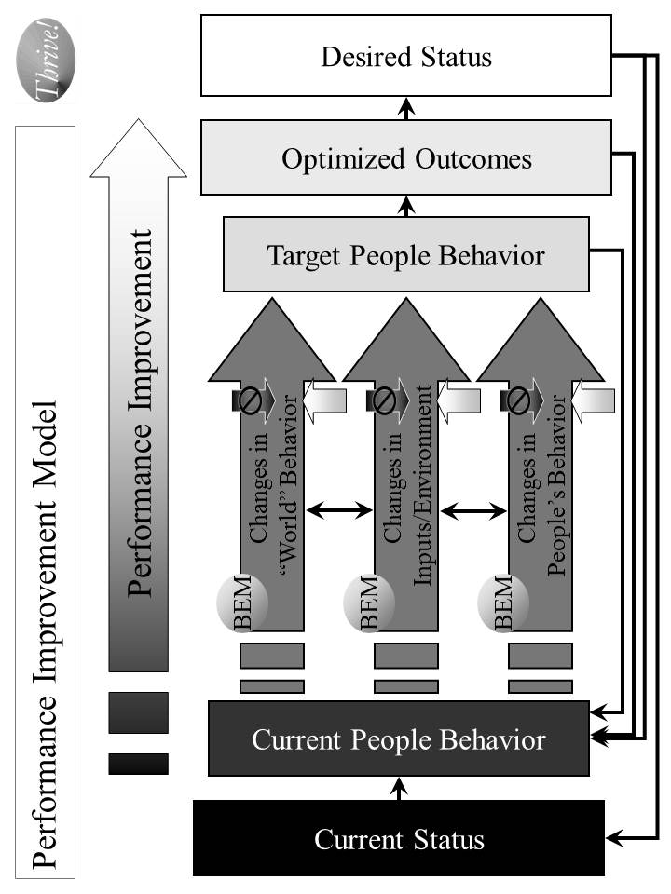
Figure A.2. Performance Improvement Model - Strategies for Improving Performance to Achieve Desired Status.
How does it work? Based on an understanding of the system that is to be improved and its current status or performance level, a desired level of status or performance is chosen. The model is designed to help determine what it will take to achieve that performance or status level. [See Table A.3.]

How has it been used and helped? The Performance Improvement Model’s primary use to date has been for improving health care quality, outcomes and status. Its potential use is being explored in creating an overall strategy for reducing vulnerability and improving the status of a community, nation or broader area.

At the Centers for Medicare and Medicaid Services (CMS), the model was used in 2006 to design an overall strategy for national quality improvement for health care, including but not limited to care funded by Medicare and Medicaid. The desired outcome was health status based on the best knowledge on how much health status can be improved through health care. The current status was based on the best available information on current health status. The model helped identify what outcomes, properly optimized, could best produce the desired health status. Further, it helped identify what target people (persons, health care personnel) behaviors could best produce those optimized outcomes. The Person Model was used to understand how individual persons do and should behave over time. The Population Model was used to understand how populations do and should behave over time. The BEM Model was used to determine what interventions would likely produce the desired behavior change. The via Model was used to determine how to apply those interventions as a coordinated, ongoing strategy. These strategies and interventions were used to enhance the overall quality improvement program for CMS.

Table A.3. Performance Improvement Model – Strategies for Improving Performance to Achieve Desired Status

The overall strategy for improving performance is as follows:
- Based on an understanding of the system that is to be improved, assess its current status or performance level.
- Determine what should be the desired level of status or performance.
- Assess what is the delta (difference) between those two levels.
- Determine what outcomes need to be produced in order to achieve the desired level of status or performance.
- Determine what people’s current behaviors are.
- Determine what people’s target behaviors should be.
- Assess what is the delta between those two sets of behavior and what behavior changes are desired.
- Determine how “world”, input/environment, and people behavior already occurring or projected to occur affect people behaviors. “World” behaviors are changes in people behaviors that are outside the system being changed. “Inputs/Environment” changes are non-people behaviors such as climate change, and plant and animal change.
- Determine the set of strategies and interventions needed to change people behaviors by using other models, including the Behavioral Effectiveness Model (BEM), the via model, and the Person and Population models. These strategies and interventions may be applied to any or all of “world”, input/environment and people behavior already occurring or projected to occur.
- Measure the effect that these strategies and interventions are having on changing people’s behavior, the outcomes and the status.
- Feed the strategies and interventions into the Overall Strategy and Supporting Strategies.
- Determine how changes in status, outcomes and behavior create a new level of “current” status, outcomes and behavior and rerun the Performance Improvement Model on an ongoing basis.

via Model.

What is it? The via Model serves as a basic framework for interventions that improve the status of an issue area (e.g., health, vulnerability, environment) or a “whole” (e.g., a non-geographic population, a community, a nation, or a broader area). [See Figure A.3.]

How does it work? As detailed in Table A.4, the via Model includes what it is we want to achieve and avoid, how to work through interventions and actions that affect that achievement, and how to measure progress.

How has it been used and helped? The via Model’s primary use to date has been for improving health care. Its potential use is being explored in creating an overall strategy for reducing vulnerability and improving the status of a community, nation or broader area.

The combination has also been used to design a HealthePeople strategy to improve health and health care across America and beyond. The same design has applicability in communities, states, and other nations.

At the Centers for Medicare and Medicaid Services (CMS), the model was used in 2006 to design the draft CMS Strategic and Operational Plan for 2007-12. It assessed current and projected actions by CMS and others affecting health status. It identified new interventions to stop actions that lower health status and to support actions that increase high and low status. New interventions were also identified that directly help achieve high and highest health status, prevent lowering of health status and move up from low health status. These via Model interventions were then used to develop the draft overall Strategic and Operational Plan for CMS.

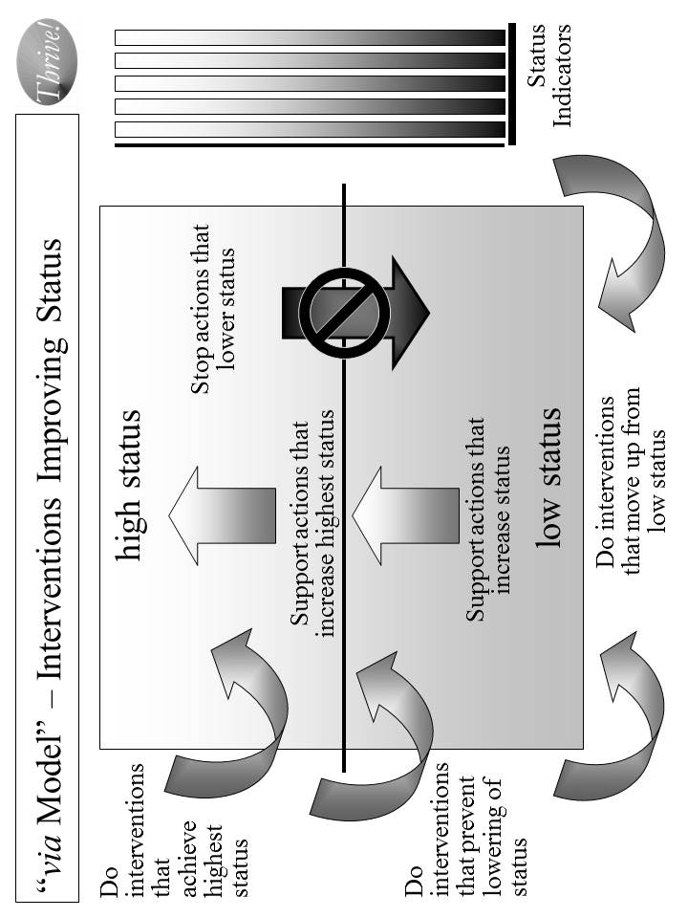

Figure A.3. “via Model” for Interventions Improving Status.

Table A.4. via Model - Interventions Improving Status

The via Model use for interventions improving status is as follows:
- Decide what issue area or “whole” needs status improvement.
- Decide what status indicators will be used to measure current and desired status.
- Identify current and projected actions that affect status in one of the following ways:
  - Actions that lower status.
  - Actions that increase status for that portion above the mean or median.
  - Actions that increase status for that portion below the mean or median.
- Identify what new interventions that positively affect status in one of the following ways:
  - Interventions that help achieve highest status, including supporting actions that further increase high or highest status.
  - Interventions that help prevent lowering of status, including stopping actions that lower status.
  - Interventions that help move up from low status, including supporting actions that increase status.
- Measure the effect that the interventions are having on the current and projected actions and on the status indicators.
- Feed the interventions into Overall Strategy and Supporting Strategies.

The model is being used on the cross-cutting issue of vulnerability. Here it is used to help create a proposed strategy for minimizing vulnerability and maximizing thriving for a whole population (e.g., a non-geographic population, a community, a nation). In this case, high status was “high thriving” and low status was “high vulnerability”. An assessment has been done on what actions are already occurring or projected to occur that will affect vulnerability. The model is being used to determine what interventions could be used to reduce vulnerability and maximize thriving.

Preliminary work has also been done on using the model for non-geographic populations, communities, nations and broader areas. That work incorporates the work done on health and vulnerability into an expanded use applicable to whole communities, nations or broader areas. The focus is on a whole population and its whole persons, along with the respective animals, plants and other natural resources. It addresses the target area as a system with subsystems (e.g. issue areas like health, income, habitat, climate) and with interactions and interdependencies with other systems (i.e., other communities, nations, and broader areas).

Behavioral Effectiveness Model (BEM).

What is it? The Behavioral Effectiveness Model (BEM) is built upon several related models from expectancy theory, instrumentality theory, theory of reasoned action, contingency theory, system theory, social cognitive theory, behavioral theory, etc. that have been in use and refined over 30-40 years. A very detailed explanation of the BEM model and its use is provided in the Appendix: Behavioral Effectiveness Model (BEM). The via approach is built upon the premise that a person or a population’s behavior is key to what creates and sustains positive change. [See Figure A.4.]

BEM’s value lies in 1) being relatively parsimonious, 2) incorporating key aspects of other behavioral models, 3) being “computable” (i.e., it can use databases (personal and environmental characteristics, desired behaviors and tailored interventions)), 4) tailoring applicability to more than one person simultaneously by using individual characteristics and desired behavior(s) and 5) using evidence-based interventions that can be tailored to those characteristics and the desired behavior.

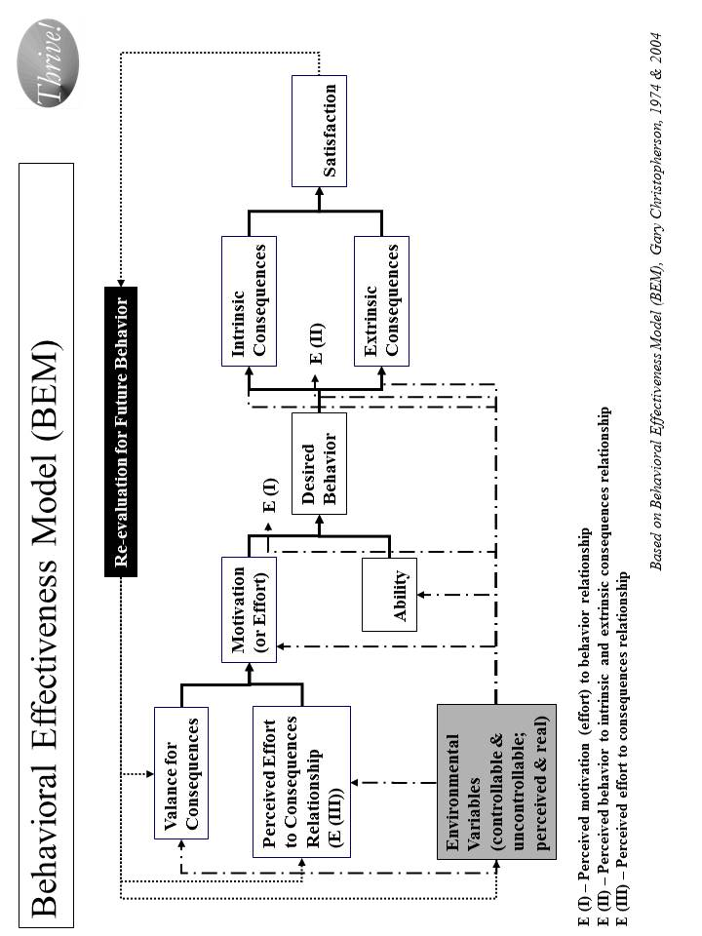

Figure A.4. “Behavioral Effectiveness Model (BEM) - Improving Personal Behavior/Performance

How does it work? As shown in Table A.5, the BEM model is designed to 1) apply interventions that help achieve the desired target behavior, 2) learn more about the person or population involved, 3) learn more about interventions and 4) learn more about the “system” in which intervention are used. It can also be used for prediction, analysis and program development and evaluation. The model can be applied to 1) an individual person, 2) populations whose characteristics are sufficiently the same, and/or 3) populations of individuals for which each individual gets a personalized and tailored intervention. The model can be linked to a database so that it can use and produce information and support personalized and tailored interventions:
- For any number of individuals and over any period of time
- For one-time behaviors and behavior over time
- For change in a single behavior and multiple behaviors.

How has it been used and helped? The Behavioral Effectiveness Model’s primary use to date has been for improving health. Its potential use is being explored in creating an overall strategy for reducing vulnerability and improving the status of a non-geographic population, a community, a nation or a broader area.

Its earliest use was in the middle 1970’s, helping develop a high blood pressure control program in Milwaukee, Wisconsin. The desired behavior was adherence to methods for controlling high blood pressure. These methods could be medication use and/or life style change (e.g., diet, exercise, stress reduction). Through the use of BEM, the program was better able to get people to get their blood pressures checked and controlled and to determine the likely success of particular methods with a specific person and with persons with similar characteristics. The blood pressure control program was seen as a national model for community blood pressure control.

Table A.5. “Behavioral Effectiveness Model (BEM)” –

Improving Personal Behavior/Performance

The BEM Model use for achieving desired behavior is as follows:
- Identify the person or population whose behavior is targeted.
- Decide what is the desired behavior or behaviors. Note that some behavior is one-time and some is recurring.
- Assess motivation in terms of its current and future characteristics.
- Assess ability in terms of its current and future characteristics.
- Assess environmental variables, both controllable and uncontrollable and both perceived and real.
- Assess how motivation, ability and environmental variables are likely to affect future behavior without further intervention.
- Assess what are likely to be the intrinsic (internal to the person or population) and extrinsic (external to the person or population) consequences of projected behavior and what is likely to be the person or population’s satisfaction.
- Assess how consequences and satisfaction are likely to affect future behavior
- Assess how projected behavior, without further intervention, matches to desired behavior.
- Assess what interventions will best move projected behavior to desired behavior for the near and long term.
- Apply the interventions and assess their effect.
- Adjust the interventions as needed over time and based on result.
- Feed the interventions into the Overall Strategy and Supporting Strategies.

BEM is also being used on the cross-cutting issue of vulnerability. Here it is being used to help identify what behaviors are associated with vulnerability and thriving. It helps identify what ability and motivational factors are and would be determinants of vulnerability and thriving behavior as well as establishing what interventions to use to reduce such vulnerability and maximize thriving.

With respect to communities, nations or broader areas, BEM is used for addressing the full breadth of issue areas and of people, animals/plants, and other natural resources. Here it helps identify what behaviors are associated with the relevant status indicators. It helps identify what ability and motivational factors are and would be determinants of improving status. The model determines what interventions could improve the motivation and ability factors and, as a result, improve status. Based on these, a strategy is being created for improving status for a whole population, in this case America as a whole.

Person Model.

What is it? The Person Model helps us to understand that each person goes through several life stages depending on how long they live. If status (e.g. health, income, performance) is to be improved, it is seldom a one-time intervention and generally should be done across the life span. As a result, the Person Model works by applying the Behavioral Effectiveness Model over an individual person’s time and life stages. [See Figure A.5.]

How does it work? The Person Model, with BEM as the underlying model, recognizes that each person is different at the beginning, throughout the life stages, and near the end. For status to be improved, the strategy needs to be both specific to each person across the life span and effective for all persons across the life span. [See Table A.6.]

How has it been used and helped? To date, the Person Model’s primary use has been for improving health. Its potential use is being explored for creating an overall strategy for reducing vulnerability and improving the status of a community, nation or broader area.

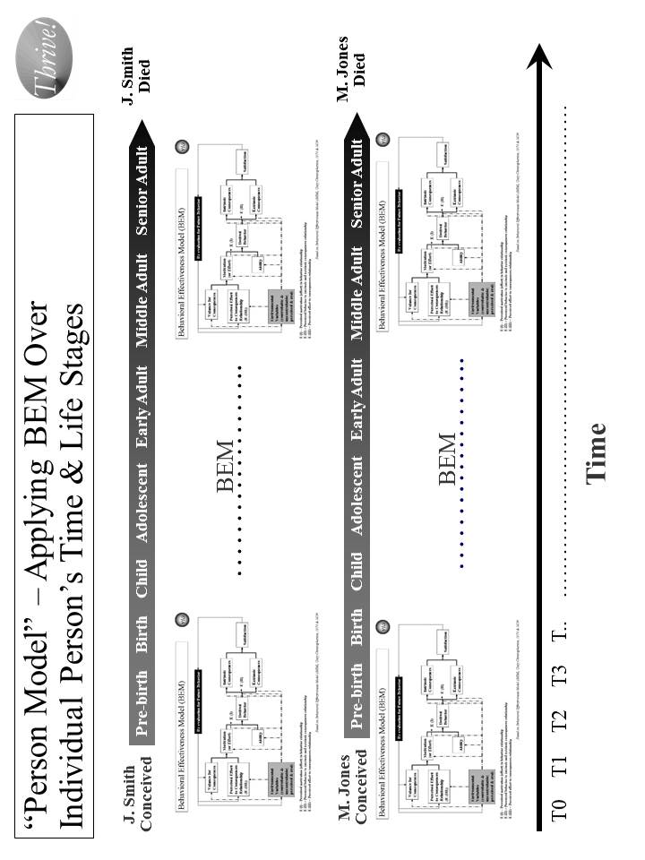
Figure A.5. “Person Model” – Applying BEM Over Each Person’s Time and Life Stages.

Table A.6. Person Model – Applying BEM Over Each Person’s Time and Life Stages

The Person Model use for achieving desired behavior is as follows:
- Identify the person or population whose behavior is targeted.
- Decide what is the time frame or life stage(s) to be addressed. The preferred time frame is the whole life.
- Decide what is the desired behavior or behaviors over time and through life stages.
- Apply BEM model as a recurring model (running the model as many times as necessary) adjusting to changes in motivation, ability and environmental variables.
- Assess what interventions will best move projected behavior to desired behavior for the covered time and life stage(s).
- Apply the interventions and assess their effect on an ongoing basis.
- Adjust the interventions as needed over time and based on result.
- Feed the interventions into the Overall Strategy and Supporting Strategies.

The model has been used to design the HealthePeople strategy to improve health and health care across America. The same design has applicability in communities, states, and other nations.
Its earliest use was in the middle 1970s to develop a high blood pressure control program in Milwaukee, Wisconsin. The desired behavior was adherence to a protocol for controlling high blood pressure over the person’s remaining life. Through the use of the Person Model, the program was better able to understand how to match the intervention to time and different life stages. With respect to time, the interventions needed during the initial treatment were different than during the maintenance phase of treatment. With respect to life stages, interventions required refining for matching the behavioral determinants for a younger versus middle-age versus older persons. The blood pressure control program served as a model of community blood pressure control programs.

At the Centers for Medicare and Medicaid Services (CMS), the model was used in 2005 to enhance the overall strategy for national quality improvement for health care. The desired behavior was of health care providers over time and their careers. The model helped identify what target health care personnel behaviors, on an ongoing basis, could produce the best outcomes. Based on that, an approach was laid out using current and new interventions to improve health care provider behavior in a way that would produce improved outcomes and health status for the foreseeable future and over the health care providers’ careers (life stages). These interventions were used to improve the overall quality improvement program for CMS.

The model was used in the early 2000s to create a new model called “person-centered health”. [See Figure A.6.] The Person-Centered Health Model has been used to refine the programs of the Veterans Health Administration, including overall care, care in the community and the VHA health information system (electronic health record and personal health record systems). It was also used at the Centers for Medicare and Medicaid Services to help with the draft strategic and operational plan.

The Person Model is also being used on the cross-cutting issue of vulnerability. Since vulnerability is relevant over a person’s whole life span and changes through the life stages, the model helps identify what ability and motivational factors, over time and across life stages, would be determinants of vulnerability and thriving behavior. It recognizes that reducing vulnerability prior to birth is very different than doing so for an adolescent or for a senior adult. Some factors (e.g. financial and cognitive ability) carry across a person’s life and can help lower vulnerability throughout a person’s life. Some factors (e.g. ability reduced by Alzheimer’s disease or low birth weight) always or most likely occur at a specific life stage.

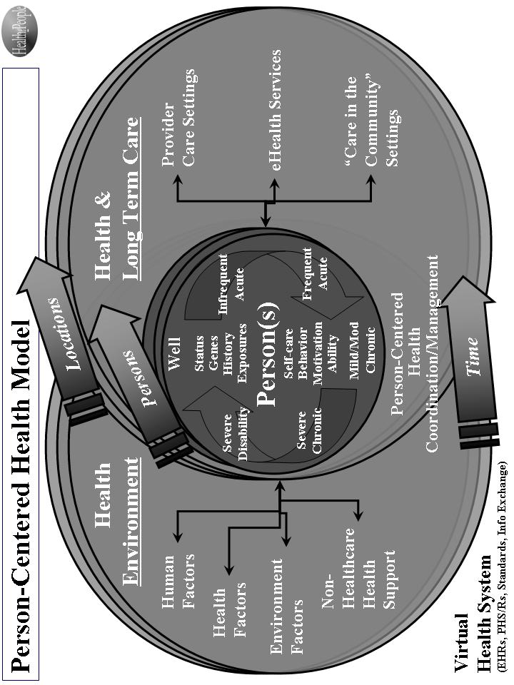

Figure A.6. Person-Centered Health Model.

Population Model.

What is it? The Population Model addresses status from the perspective of what is happening at any point in time and the effect on a diverse or non-diverse population. Again, BEM is the underlying model for adjusting strategy to address points in time across persons and their life stages. This model also applies to other differences (e.g., racial, ethnic, income, vulnerability) in the target population [See Figure A.7.]

How does it work? The Population Model, with BEM as the underlying model, recognizes that strategy, at any point in time, must be both specific to each applicable person across the life span and effective across all persons across the life span. [See Table A.7.] Taking a time slice, the model recognizes that at any specific time, the target population likely includes persons from all different stages of life (pre-birth, birth, child, adolescent, early adult, middle adult and senior adult). At that time, each person has different status levels, different factors affecting status, and different responses to endeavors at improving status. This can be seen in how major disasters (e.g., tsunamis, earthquakes, disease outbreaks, crop failures, drought) affect people differently. This can be seen in how program interventions (e.g. education, housing programs, financial assistance, health insurance programs, heating assistance, taxes) affect people differently.

How has it been used and helped? The Population Model’s primary use to date has been for improving health. Its potential use is being explored for creating an overall strategy for reducing vulnerability and improving the status of a community, nation or broader area.

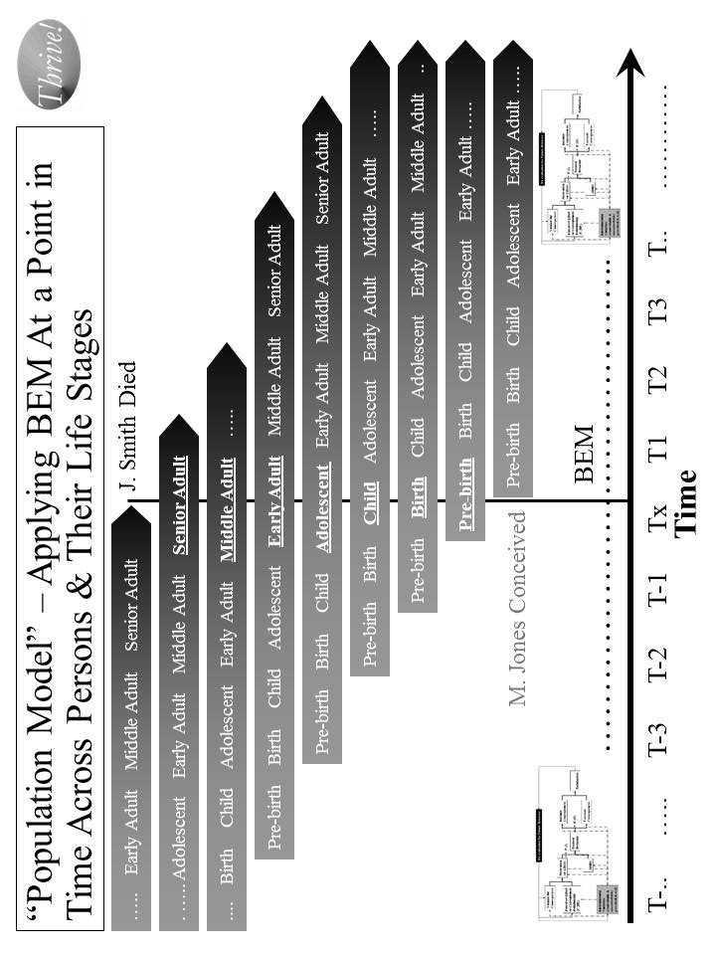
Figure A.7. “Population Model” – Applying BEM at a Point in Time Across Persons and Their Life Stages

Table A.7. Population Model – Applying BEM at a Point in Time Across Persons and Their Life Stages

The Population Model use for achieving desired behavior is as follows:
- Identify the population whose behavior is targeted.
- Decide what are the point(s) in time and life stage(s) to be addressed.
- Decide what is the desired behavior or behaviors at different points in time across persons and their life stages.
- Apply the BEM model across time and across populations and their life stages taking into account their differing motivation, ability and environmental variables.
- Assess what interventions will best move projected behavior to desired behavior across time and across populations and their life stages.
- Apply the interventions and assess their effect on a population on an ongoing basis.
- Adjust the interventions as needed over time and based on result.
- Feed the interventions into the Overall Strategy and Supporting Strategies.

At the Centers for Medicare and Medicaid Services (CMS), the model was used in 2006 to design the draft CMS Strategic and Operational Plan for 2007-12. It was used to address CMS’s disparate beneficiary population and the timing and design of program interventions. The plan was designed to address the needs of both younger and older Medicaid beneficiaries, beneficiaries with disabilities, and healthier and severely ill Medicare beneficiaries. It also addressed the populations that are pre-Medicaid and pre-Medicare. The plan recognized that over time, these populations change as new age cohorts moved into the program. These Population Model interventions were then used to develop the draft overall Strategic and Operational Plan for CMS.

For the DoD Military Health System (MHS), the model was used in the 1990s to work with pre-military, active service, Guard and Reserve, veterans, retirees and their families. All are the responsibility of the MHS. Key points in time greatly affect how the health programs work and their effect. Earlier wars (and their effects) such as the two World Wars and the Korean War are very different than the Vietnam War than the first Iraq War, as well as the second Iraq War and then the Afghanistan operations. They are all likely to be different than future wars and other military actions. All of these factors were built into the overall strategy for the future Military Health System that was re-engineered to improve performance, adopted as a force health protection program, and was made more flexible to adjust to different futures.

The model has also been used to design a HealthePeople strategy to improve health and health care across America. The same design has applicability in communities, states, and other nations.

The Population Model is also being used on the cross-cutting issue of vulnerability. Since vulnerability is relevant at different points across a person’s life stages, it is used to help identify what ability and motivational factors at those different points are most likely determinants of vulnerability and thriving behavior. For example, applying new policies on financial assistance or taxes over the next twelve months will have very different effects across the population of persons. If the intent of the new policies is reducing financial vulnerability across the U.S. population, then they must be modeled, at a minimum, against each subpopulation and, preferably, against each “person”. The more desirable policies are those that both reduce vulnerability most for the most vulnerable and substantially reduce vulnerability for all persons. The most desirable policies are the ones that do this and continue the positive effect as the population moves through time (i.e., sustainable, reduced vulnerability for all people). As indicated earlier, the overall strategy has not been used to date, but is ready for application.

System(s) Model (Including “Ideal” Systems).

What is it? The System(s) Model views the world as a system of systems. When a strategy is being designed, it is important to determine what the target system is, what larger system it is part of, what its subsystems are, and what other systems it relates to. A system can be a community, a nation, or a broader area. It can be an issue area system such a health system, an education system, or an ecological system. The Ideal Systems Model, developed by people such as industrial engineers (e.g. Gerald Nadler) decades ago, is another key model for looking at how well a system could perform and how to achieve the highest performance for that system. [See Figure A.8.]

How does it work? For endeavors to improve status to be successful and sustainable, the strategy and its execution need to be systematic and positively change a system (a whole community, a whole nation or a whole broader area) of systems (e.g., health, education, employment/income, housing, habitat, climate) on a sustained basis. [See Table A.8.]

In a systems model, there is recognition that systems are “living”. They change internally, impact other systems and are impacted by other systems. Systems are part of other systems and they have subsystems themselves. They are usually complex. They often overlap with other systems. They interact with other systems, sometimes fairly predictably and sometimes not. They often have permeable borders that are not always understood or constant. They may be nearly infinite in number. Often we apply an artificial construct to them to help us understand and work with them. Some systems are formal constructs (e.g., the British National Health Service system, the Kaiser Permanente system, the Military Health System, the veterans health system) and some are informal constructs (e.g. the American “health system”). They may be or appear to be “chaotic” or “ordered”. They may be or appear to be “real”.

To positively change a system (e.g. the American “health system”) on a sustained basis, we need to understand the impact that existing and future systems will have on each person’s or a population’s status. We need to understand the impact of systems that we create, change or delete will have on other systems and, ultimately, on each person’s status.

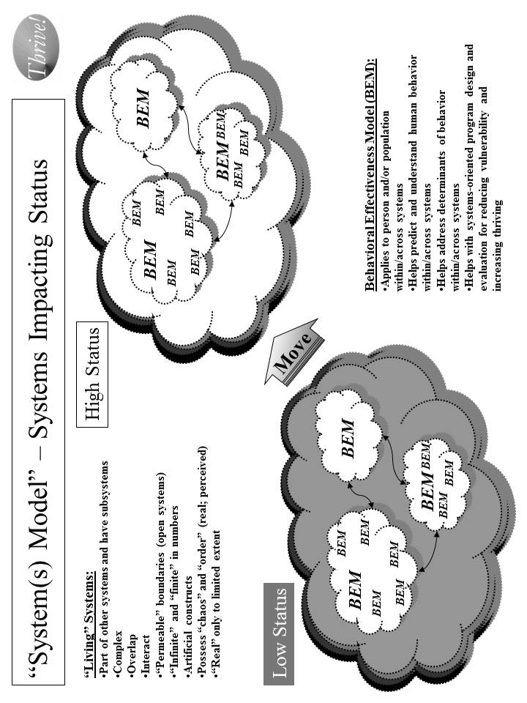

Figure A.8. Systems Model – Systems Impacting Status

Table A.8. Systems Model – Systems Impacting Status

The Systems Model use for achieving desired status is as follows:
- Identify the target system within which status is to be improved.
- Identify other systems that are related and might either be impacted or have an impact.
- Identify the status (lower than desired) for the current system and key characteristics of the current system.
- Identify the desired status and characteristics for the future system using the Ideal Systems Model.
- Identify the key behaviors in the current systems and what they need to be in the future system.
- Determine what changes need to be made to the current system to move it to the desired system.
- Assess what interventions will best change the current system into the desired future system.
- Apply the interventions and assess their effect on behavior change and on status.
- Adjust the interventions as needed over time and based on result.
- Feed the interventions into the Overall Strategy and Supporting Strategies.

Within “human” systems are real people (individual persons, populations of persons) and organizations (made up of persons) whose behaviors collectively help determine the behavior of the system. The Behavioral Effectiveness Model (BEM) helps us understand the behaviors and their determinants (ability, motivation, environmental factors) on an individual level and on a population of individuals level. In the systems model used here, there is recognition that moving from low status to high status requires moving individual behavior on a massive scale if it is a large system like the American “health system”. This movement includes the persons we want to move to higher status and the persons that help or hinder that movement.

As shown in Figure A.9, the Ideal Systems Model helps determine the desired system. It starts out by assessing the current system. It then sets what is the theoretical ideal system assuming there are no costs or constraints preventing us from reaching that system. The theoretical ideal is a guide but is not reachable in the real world for the foreseeable future. Then the model helps us think through the options between the current system and the theoretical ideal system. The ultimate ideal system is one which imposes no constrains but is not yet feasible due to the “means” not yet being available. The feasible ideal system is one where the constraints are removed or reduced and the “means” are available. Finally, the recommended system is the best given the constraints and available means and is on the glide path to the ultimate ideal. The via Model helps design and assess these different systems.

How has it been used and helped? The primary use of the System Model (this adapted version) to date has been for improving health. Its potential use is being explored in creating an overall strategy for reducing vulnerability and improving the status of a community, nation or broader area.

One of its earliest uses was in the late 1970s to design and execute an inner city health system for Milwaukee, Wisconsin. The result was a new public/private multi-clinic system providing preventive services, primary care, maternal and infant care, mental health care, dental care, and social services for the community poorest and highest risk people. The total system also included hospital services from public and private hospitals. The system operated successfully for over 30 years and has been viewed as a successful model for improving inner city health care.

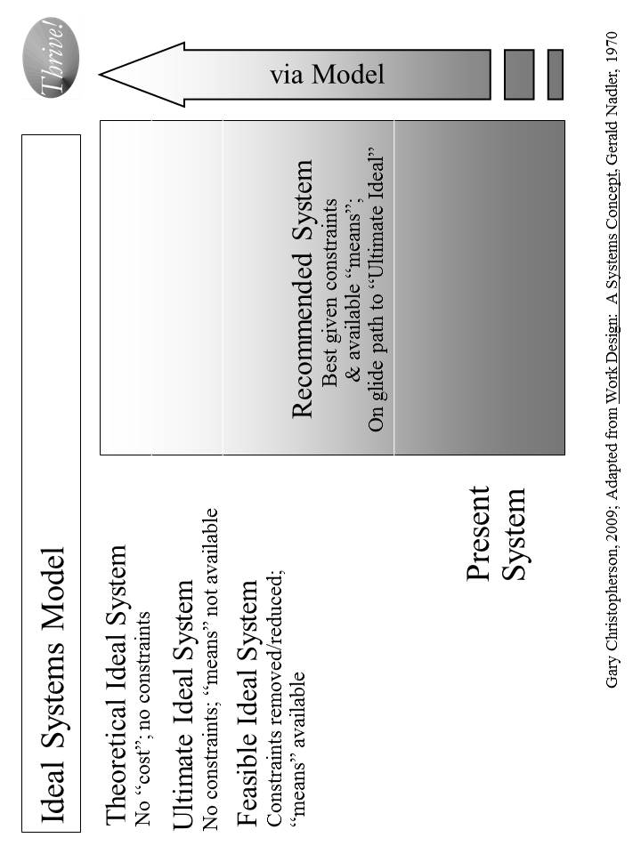

Figure A.9. Ideal Systems Model

At the Centers for Medicare and Medicaid Services (CMS), the Systems Model was used in 2006 to design the draft CMS Strategic and Operational Plan for 2007-12. Rather than approaching the plan as a program by program plan or a CMS only plan, the whole American “health system” was used as the framework. The plan was designed using the Ideal Systems Model to improve health across the total American population using the entire American “health system”. The CMS plan strategies were built on how best to move to high health status by using both CMS programs focused on Medicare and Medicaid beneficiaries and programs with broader scope. For example, CMS’s quality improvement program has impact far beyond care for CMS beneficiaries. Similarly, CMS’ payment programs serve as the driver for non-CMS payment programs (e.g. health insurers). The plan was designed to address the needs of both younger and older Medicaid beneficiaries, beneficiaries with disabilities, and healthier and severely ill Medicare beneficiaries. It also addressed the populations that are pre-Medicaid and pre-Medicare. These Systems Model interventions were then used to develop the draft overall strategic and operational plan for CMS.

For the Department of Defense (DoD) Military Health System (MHS), the model was used in the middle 1990s to work with full set of DoD health-related programs. The Military Health System was treated as a system that encompassed health care for 1) service members when not engaged in military action, 2) service members (including the Guard and Reserve) when engaged in military action, and 3) family members, retirees, Guard and Reserve in non-active status, veterans served by other providers (e.g., Veterans Health Administration and private providers). It also encompassed preventive services for service members, and force health protection (including protective tools when deployed). The overall MHS strategy was built using the Ideal Systems Model coupled with other “futures” models. It included the health of all of these people. The strategy included all the services needed to protect and improve their health. It included working with other entities, including the Veterans Health Administration and the Centers for Disease Control. All of this was built into the overall strategy for the future Military Health System that was re-engineered, adopted a force health protection program, was more effective and efficient, and was more flexible to adjust to different futures.

The model has also been used to design a HealthePeople strategy to improve health and health care across America. The same design has applicability in communities, states, and other nations.

The Systems Model is also being used on the cross-cutting issue of vulnerability. Since vulnerability is both personal and heavily affected by the “system” in which people live, the model is the best way to address both. Similar to what is shown in Figure A.8, the idea is to move from low status (high vulnerability and low thriving) to high status (low vulnerability and high thriving). To best accomplish that, the Systems Model is being used to address the whole system (e.g. the United States) but has its impact on the person level. The Ideal System Model is used to determine what overall strategy would not only minimize vulnerability and maximize thriving at a point in time but to do it on a sustained basis. The strategy identifies what status measures would be relevant at the system-wide level and at the individual person level. It identifies what interventions and actions would both reduce vulnerability most for the most vulnerable and reduce vulnerability substantially for all persons. The Ideal Systems Model is being used to ensure the strategy is one that does this in both the near and long term.

The model’s application is being explored for whole communities, nations and broader areas where these are treated as total systems interacting with other systems outside. Building an appropriate set of status indicators is a critical step given the breadth of such systems and the need to assess current and desired future status. The focus is on the whole human population (as well as its individual whole persons), and on animals, plants and natural resources within the targeted community, nation or broader area. The full range of significant issue areas within the target community, nation or broader areas is explored, including their interaction and interdependency. The Ideal Systems model is used to both set the vision and design the recommended systems for now and for the future. The intended result is an overall, sustainable, executable strategy for improving the status of a community, a nation or a broader area.

Strategy Model.

What is it? The Strategy Model builds on the above groundwork and brings this all together to develop and execute stainable, effective strategies for improving status. It includes the model for building the strategies as well as the framework into which the strategies fit. The model includes both the overall strategy and supportive strategies and the actual interventions supporting the strategies. [See Figure A.10.]

How does it work? The model brings together all the previous information into an overall strategy and supportive strategies to improve status (e.g. health, income, vulnerability, habitat, climate). [See Table A.9.]

How has it been used and helped? The Strategy Model’s primary use to date has been for improving health. Its potential use for creating an overall strategy for reducing vulnerability and improving the status of a community, nation or broader area is being explored.

At the Centers for Medicare and Medicaid Services (CMS), the Strategy Model was used in 2006 to design the draft CMS Strategic and Operational Plan for 2007-12. The result of that endeavor was a plan similar to what is shown in Figure A.11. For each of the supportive strategies, a set of specific interventions were developed to make the plan fully operational. With respect to quality improvement for CMS, a more in-depth strategy was developed using the Strategy Model.

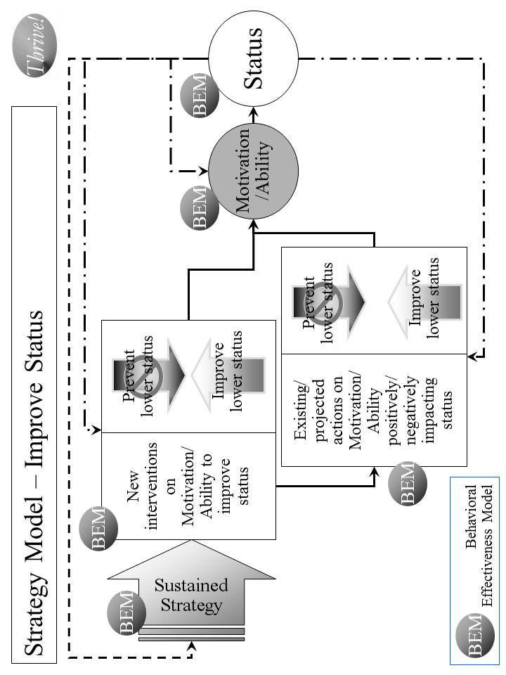

Figure A.10. “Strategy Model” – Improve Status

Table A.9. Strategy Model – Improve Status

The Strategy Model use for achieving desired status incorporates previous work from the other models and input and is as follows:
- Load the desired status and the associated indicators.
- Load the optimized outcomes that will best produce high status.
- Load the target behaviors that will best produce the optimized outcomes.
- Use pathways to connect how the supportive strategies will best produce the target behavior. The pathways are customized to the issue area or “whole”.
- Identify the specific supportive strategies that, working through the pathways will best produce the target behaviors.
- Execute the strategy and its supportive strategies effectively.
- Assess the progress on improving status. Assess the effectiveness of the strategy and its supportive strategies.
- Revise strategy and supportive strategies as needed to be effective and sustained over time.

The model is being used on the overall American health system. It is being used to try to answer how could we “achieve a healthy America” using an enhanced whole American health system. With many similarities to the CMS Plan, the strategy model helps create a strategy, HealthePeople, but with the larger scope of all Americans, all payers and all health providers.

The Strategy Model is also being used on the cross-cutting issue of vulnerability.

Similarly, it is being used to build an overall strategic approach, Thriving Future, addressing whole communities, nations and broader areas.

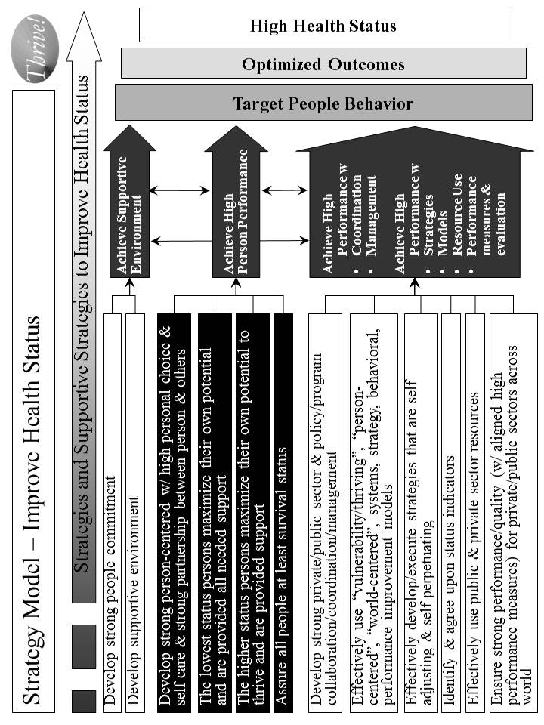
Figure A.11. Strategy Model – Improve Health [and Functional] Status

Status Model.

What is it? The Status Model is used to identify the desired and current status for “whole” systems (e.g., a non-geographic population, a community, a nation, a broader area), issue areas (e.g., health, education) or cross-cutting issue areas (e.g., vulnerability, climate, habitat) that are targeted for positive, large scale change. It also includes the status indicators and their supportive measures such as those shown in Figure A.12.

How does it work? For endeavors to create and sustain positive systems to be successful, we need to determine how we are doing today, how we are doing as we progress to the desired system and how we are doing when we achieve and work to sustain the desired system. The Status Model helps do that as shown in Table A.10.

How has it been used and helped? The Status Model’s primary use has been for improving health. Its potential use is being explored in creating an overall strategy for reducing vulnerability and improving the status of a community, nation or broader area.

In both the draft CMS Strategic and Operational Plan (2006) and the work being done on how to “achieve a healthy America”, the model’s applications are similar. Both include status indicators that apply across America. Both depend on more detailed measures to support and add depth to the indicators. The CMS approach focused a bit more on CMS beneficiaries but did include all Americans. The “healthy America” approach uses status indicators that apply to all Americans. The health status indicators address the person’s ability and motivation to achieve high health status. The same is true for health care providers. These are more process indicators. The status indicators include outcomes of various treatments and other health interventions. The status indicators go further and include what most consider as “health status” indicators such as low morbidity and mortality, high quality of life, high satisfaction, and low future risk for adverse events. Current status is assessed as well as the negative gap between the desired future high health status and current lower health status.

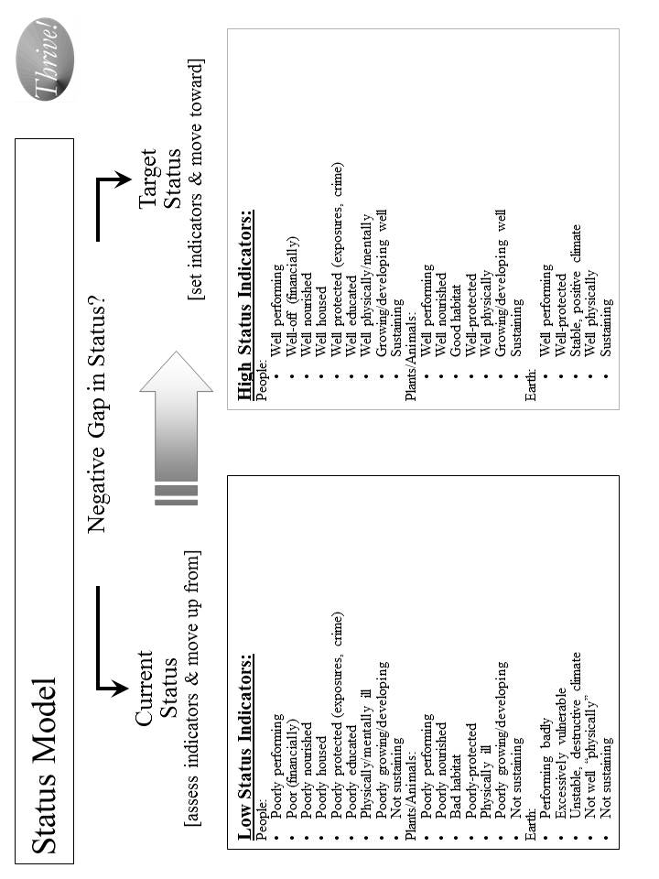

Figure A.12. Status Model

Table A.10. Status Model

The Status Model is as follows:
- Determine what is the issue area, cross-cutting area or “whole” system for which the strategy is targeted and status indicators are needed.
- Decide how high, in general, is the desired status. Is it optimal? If not, how close can we get to optimal?
- Identify all of the indicators that, as a set, indicate the desired high status. These are the “Target Status” set of indicators.
- Decide what each indicator’s level should be to match the desired high status.
- Decide what each indicator’s level is to describe low status.
- To the extent needed, identify more detailed measures for each indicator.
- Assess the “Current Status”, i.e., the current level of indicators for the target population.
- Assess the “Negative Gap” between the current status and the desired target status. This is the gap to be closed with the overall strategy.
- Execute the status model effectively and measure progress.
- Assess the effectiveness of the status indicators.
- Revise status indicators, individually and as a set, as needed to be effective.

The model is being used on the overall American health and to answer what is a “healthy America”. With similarities to the CMS Plan, the status model helps support a strategy, HealthePeople, with the larger scope of all Americans and all health providers. [See Figure A.13.]

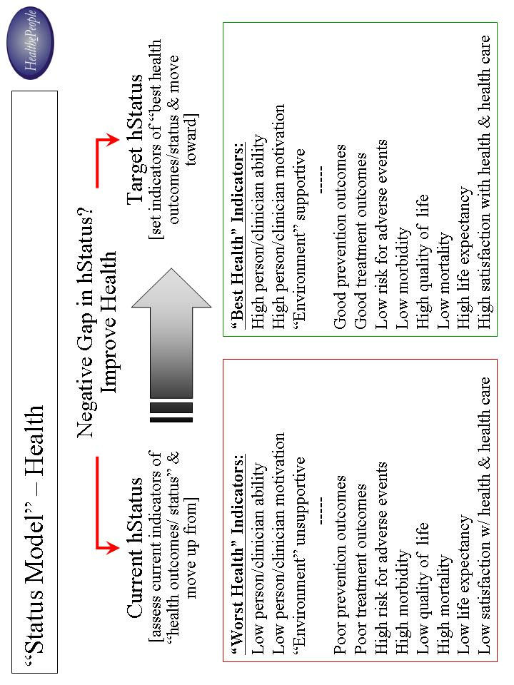

Figure A.13. Status Model - Health

For the broader work on communities, nations and broader areas, the full set of status indicators is very large but can be grouped into high level categories with supportive measures. They should encompass all the significant indicators covering the full breadth of the target area. On the highest level, they must be meaningful enough to provide guidance on improving the whole target area as a whole system. They must be supported by clearly defined measures that can be measured by data that is available into the future. Further, the status indicators must be flexible enough to adjust to changing future conditions. With these status indicators, a strategy can be developed and its progress assessed.

The Path Ahead

Potential “next generation” models do exist for strategy at system (issue area, community, nation, broader area) and person levels. As proposed here, one such model is the Thrive! Next Generation Toolkit - a core set and system of supportive models addressing persons, systems, motivation, ability, behavior, performance and its improvement, process measures, and, most importantly, positive outcomes and improved status. While parts of the strategy can be used independently, they have more power and are more likely to produce the best results when used as a full set.

The path ahead offers many opportunities, as outlined above, to tackle large, complex issue areas, cross-cutting issues and whole communities and nations. Already late, now is the time to aggressively use “next generation” strategies for solving large problems and creating and sustaining positive, large scale change and a surviving and thriving future for all forever, to the maximum extent possible.

viaFuture (path and means to the future) is the term used in other settings for the underlying strategies, models and tools for the next generation toolkit. The via name is used because its definition is “by way of, through the medium or agency of, or by means of.”
You might also want to use Thrive! - Building a Thriving Future, the previous book, which provides greater depth on strategy and tools and is available via www.Amazon.com or as free download from www.ThrivingFuture.org.

