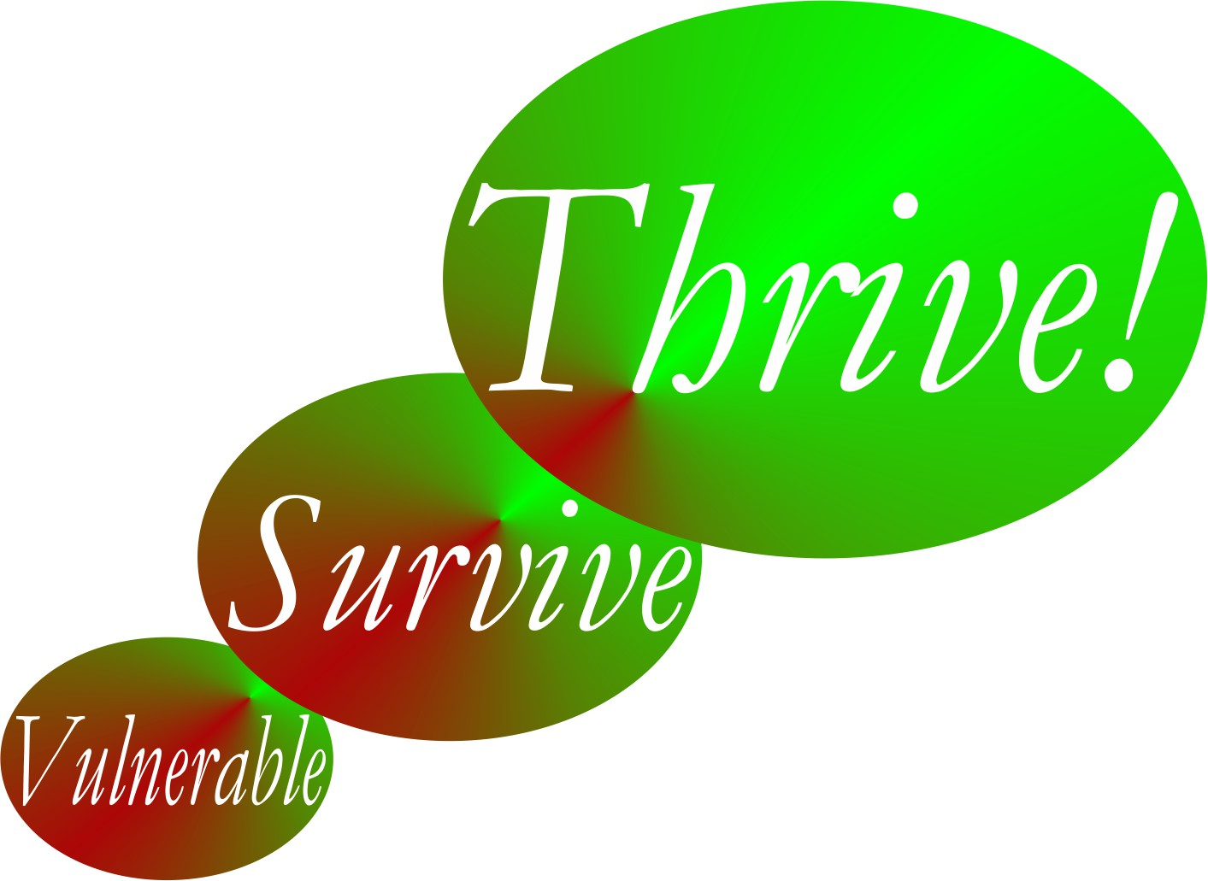

Thrive!® - People’s Guide To A Thriving Future

[For All Forever]

Worksheets for You and Your Family and Friends

Final Draft

by

Gary Chris Christopherson

Founder of
Thrive!® - Building a Thriving Future for All Forever
HealthePeople® - Building a Healthy and Thriving Future

Nelson, WI University Park, MD

Copyright © 2014 Gary Chris Christopherson All rights reserved.

Current and Future Persons (name) | For each person, have the person independently do a one-paragraph description in her/his own words. If the person can’t, do one for the person. Cover things like work/living/playing, financial situation, eating/drinking, housing, protection, education, physical/mental health, growth/development, habitat, producing what, and climate. Enter the descriptions into this worksheet/table. Do a summary of your people as a whole.
Your current and future people as a whole. [Summary]
Table 4.1. Who are your current and future people?

Current/Future Person: __________________________ (Do separate one for each person)
Thriving and Surviving | How well (thriving/surviving) is the person? | What positively/negatively impacts her/his thriving/surviving? | What is her/his near/ long term future behavior as to thriving/surviving?
Performing (live/work/play) well?
Well-off?
Well nourished?
Well housed?
Well protected?
Well educated?
Physically/ mentally well?
Growing/ developing well?
Living in good habitat?
Not vulnerable?
Producing personal/ public goods?
Stable, positive climate?
Sustainable?
Table 4.2a. How well (surviving/thriving) is the person? What positively/negatively impacts the person? What is her/his near/long term future behavior?

Thriving and Surviving | How well (thriving/surviving) are your people as a whole? | What positively/ negatively impacts their thriving/ surviving? | What is their near/ long term future behavior as to thriving/surviving?
Performing (live/work/play) well?
Well-off?
Well nourished?
Well housed?
Well protected?
Well educated?
Physically/ mentally well?
Growing/ developing well?
Living in good habitat?
Not vulnerable?
Producing personal/ public goods?
Stable, positive climate?
Sustainable?
Table 4.2b. How well (surviving/thriving) are your people as a whole? What positively/negatively impacts them? What is their near/long term future behavior?

Thriving and Surviving | How well (thriving/surviving) should your people as a whole be in near/long term future? | External/ internal changes needed to achieve thriving/ surviving future | External actions by others - Who externally will do what to/with whom, where, when, and with what result? How to make that happen? | Internal actions by your people - Who of your people will do what to/with whom, where, when, and with what result
Performing (live/work/ play) well?
Well-off?
Well nourished?
Well housed?
Well protected?
Well educated?
Physically/ mentally well?
Growing/ developing well?
Living in good habitat?
Not vulnerable?
Producing personal/public goods?
Stable, positive climate?
Sustainable?
Table 4.3a. Thrive! Strategy and Action Plan. How well (surviving/thriving) should your people as a whole be in near/long term future? What external/internal changes are needed to achieve your people’s thriving future? To make this happen, what external/internal actions are needed?
Thriving and Surviving | How well (thriving/surviving) should your people as a whole be in near/long term future? | External/internal changes needed to achieve thriving and surviving future | Actions by your people and others - Who will do what to/with whom, where, when, and with what result?
Performing (live/work/ play) well? |  | External: | External by others:
Performing (live/work/ play) well? |  | External: | Internal by your people:
Performing (live/work/ play) well? |  | Internal: | Internal by your people:
Well-off? |  | External: | External by others:
Well-off? |  | External: | Internal by your people:
Well-off? |  | Internal: | Internal by your people:
Well nourished? |  | External: | External by others:
Well nourished? |  | External: | Internal by your people:
Well nourished? |  | Internal: | Internal by your people:
Well housed |  | External: | External by others:
Well housed |  | External: | Internal by your people:
Well housed |  | Internal: | Internal by your people:
Well protected? |  | External: | External by others:
Well protected? |  | External: | Internal by your people:
Well protected? |  | Internal: | Internal by your people:
Well educated? |  | External: | External by others:
Well educated? |  | External: | Internal by your people:
Well educated? |  | Internal: | Internal by your people:
Physically/ mentally well? |  | External: | External by others:
Physically/ mentally well? |  | External: | Internal by your people:
Physically/ mentally well? |  | Internal: | Internal by your people:
Growing/ developing well? |  | External: | External by others:
Growing/ developing well? |  | External: | Internal by your people:
Growing/ developing well? |  | Internal: | Internal by your people:
Living in good habitat? |  | External: | External by others:
Living in good habitat? |  | External: | Internal by your people:
Living in good habitat? |  | Internal: | Internal by your people:
Not vulnerable? |  | External: | External by others:
Not vulnerable? |  | External: | Internal by your people:
Not vulnerable? |  | Internal: | Internal by your people:
Producing personal/ public goods? |  | External: | External by others:
Producing personal/ public goods? |  | External: | Internal by your people:
Producing personal/ public goods? |  | Internal: | Internal by your people:
Stable, positive climate? |  | External: | External by others:
Stable, positive climate? |  | External: | Internal by your people:
Stable, positive climate? |  | Internal: | Internal by your people:
Sustainable? |  | External: | External by others:
Sustainable? |  | External: | Internal by your people:
Sustainable? |  | Internal: | Internal by your people:
Table 4.3b. Thrive! Strategy and Action Plan. How well should your people as a whole be in near/long term future? What external/internal changes are needed to achieve your people’s thriving future? To make this happen, what external/internal actions are needed?

