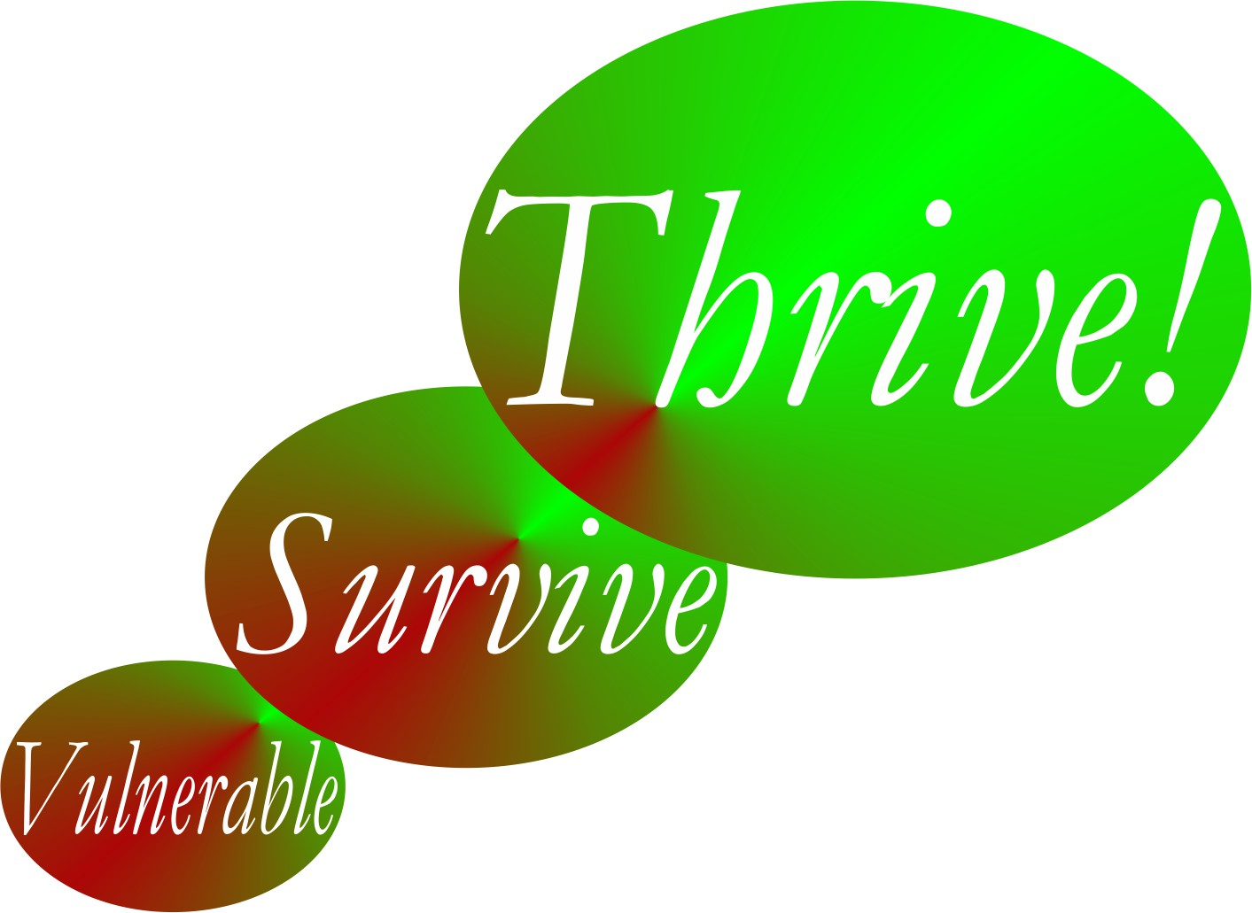

Thrive!® - People’s Guide To A Thriving Future

[For All Forever]

Worksheets for You and Your Community

Final Draft

by

Gary Chris Christopherson

Founder of
Thrive!® - Building a Thriving Future for All Forever
HealthePeople® - Building a Healthy and Thriving Future

Nelson, WI University Park, MD

Copyright © 2014 Gary Chris Christopherson All rights reserved.

Community Characteristics | What is your community today?
Geographic boundaries
Gender make-up
Age make-up
Racial make-up
Ethnic make-up
Lifestyle
Type of work
Financial situation
Food/drink
Housing
Protection
Education
Physical / mental health
Personal growth / development
Habitat
Producing what
Climate
Sustainability
Table 5.1. What is your community today?

Thriving and Surviving | How well (thriving/surviving) is your community? | What positively/negatively impacts its thriving/ surviving now? | What is its near/ long term future behavior as to thriving/ surviving?
Performing (live/work/play) well?
Well-off?
Well nourished?
Well housed?
Well protected?
Well educated?
Physically/ mentally well?
Growing/ developing well?
Living in good habitat?
Not vulnerable?
Producing personal/ public goods?
Stable, positive climate?
Sustainable?
Table 5.2. How well (thriving/surviving) is your community? What positively/negatively impacts it? What is its near/long term future behavior?

Community Characteristics | What is your desired and/or likely future community?
Type of work/how people live
Financial situation
Food/drink
Housing
Protection
Education
Physical / mental health
Personal growth / development
Habitat
Producing what
Climate
Sustainability
Table 5.3. What is your desired and/or likely future community?

Thriving and Surviving | How well (thriving/surviving) should your community be in near/long term future? | External/internal changes needed to achieve thriving and surviving future. | Actions by your community and others - Who will do what to/with whom, where, when, and with what result?
Performing (live/work/ play) well? |  | External: | External by others:
Performing (live/work/ play) well? |  | External: | Internal by your community:
Performing (live/work/ play) well? |  | Internal: | Internal by your community:
Well-off? |  | External: | External by others:
Well-off? |  | External: | Internal by your community:
Well-off? |  | Internal: | Internal by your community:
Well nourished? |  | External: | External by others:
Well nourished? |  | External: | Internal by your community:
Well nourished? |  | Internal: | Internal by your community:
Well housed |  | External: | External by others:
Well housed |  | External: | Internal by your community:
Well housed |  | Internal: | Internal by your community:
Well protected? |  | External: | External by others:
Well protected? |  | External: | Internal by your community:
Well protected? |  | Internal: | Internal by your community:
Well educated? |  | External: | External by others:
Well educated? |  | External: | Internal by your community:
Well educated? |  | Internal: | Internal by your community:
Physically/ mentally well? |  | External: | External by others:
Physically/ mentally well? |  | External: | Internal by your community:
Physically/ mentally well? |  | Internal: | Internal by your community:
Growing/ developing well? |  | External: | External by others:
Growing/ developing well? |  | External: | Internal by your community:
Growing/ developing well? |  | Internal: | Internal by your community:
Living in good habitat? |  | External: | External by others:
Living in good habitat? |  | External: | Internal by your community:
Living in good habitat? |  | Internal: | Internal by your community:
Not vulnerable? |  | External: | External by others:
Not vulnerable? |  | External: | Internal by your community:
Not vulnerable? |  | Internal: | Internal by your community:
Producing personal/ public goods? |  | External: | External by others:
Producing personal/ public goods? |  | External: | Internal by your community:
Producing personal/ public goods? |  | Internal: | Internal by your community:
Stable, positive climate? |  | External: | External by others:
Stable, positive climate? |  | External: | Internal by your community:
Stable, positive climate? |  | Internal: | Internal by your community:
Sustainable? |  | External: | External by others:
Sustainable? |  | External: | Internal by your community:
Sustainable? |  | Internal: | Internal by your community:
Table 5.4. Thrive! Strategy and Action Plan. How well (thriving/surviving) should your future community be in near/long term future? What external/internal changes are needed to achieve your community’s thriving future? To make this happen, what external/internal actions are needed?

